From
“A Summary of the Christian Faith”
by David Chytraeus (1568)

On the Resurrection of the Dead.

On the Last Day, God, by His omnipotent Word, will raise the bodies of all dead men and unite them with their souls, and the wicked will endure eternal punishment with the devil, and those who are pious and doing good works will gain eternal rewards in heaven.

What is new obedience?

... Good works, or the worship of God, are the actions of the mind, will, heart and external members which God has commanded, which the Holy Spirit has aroused and which we have done in faith to this end: that we show God and honor.
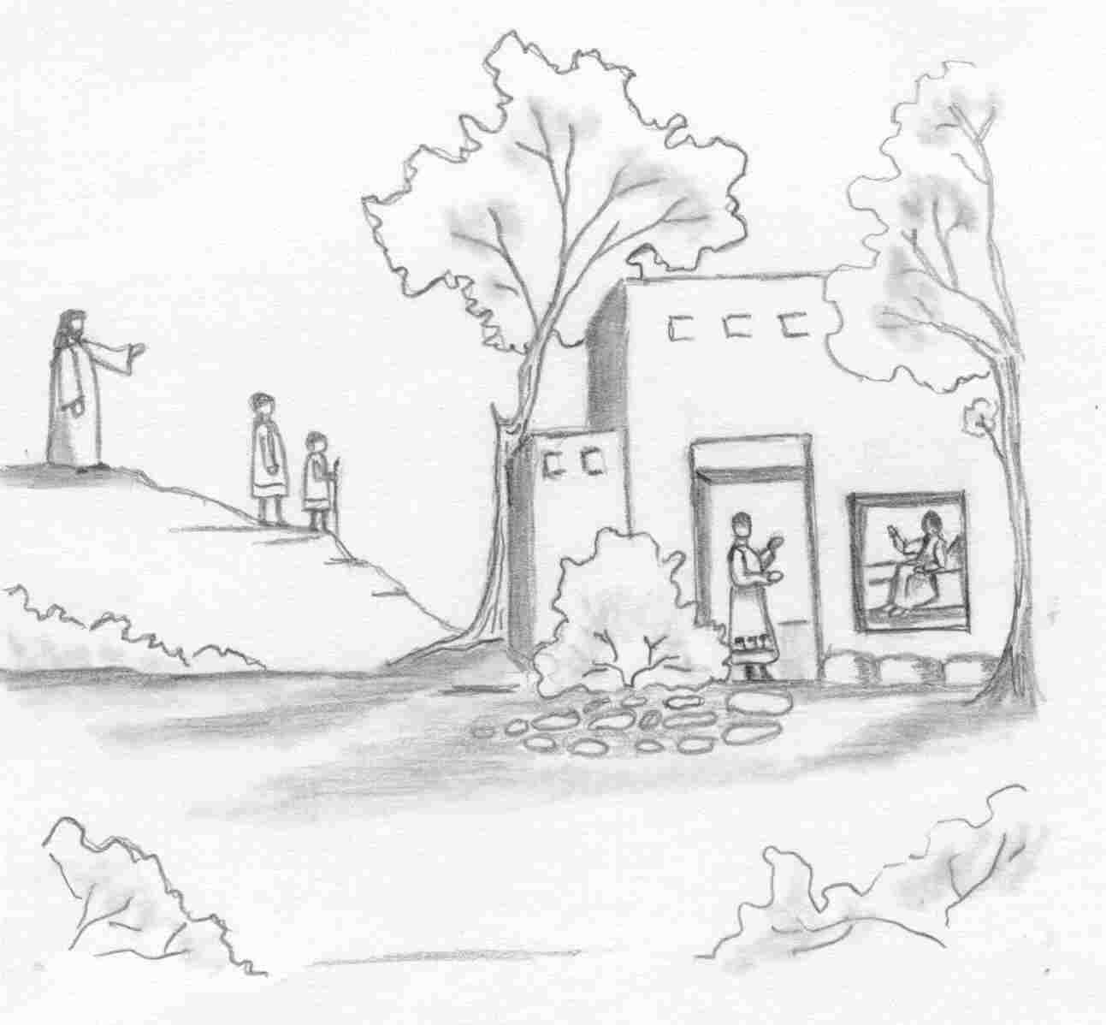
But say the Word,
and my servant will be healed.
Our Redeemer Lutheran Church
403 South Hayes
Emmett, Idaho 83617 Church: 208-365-5231

Pastor: Rev. Michael L. McCoy
parsonage: 208-365-5214
email: mmccoy19@earthlink.net
www.scholia.net – the website for:
Good News for the Diaspora!
scholia.net publishing – Where the Word is not Bound
Predici in limba romana – (Sermons in Romanian)
The artwork is by Sharon Geiser. Permission to use this copyrighted graphic is limited to congregational use. The quotation above is by David Chytraeus and is from his 1568 work A Summary of the Christian Faith. The English translation is by Rev. Dr. Richard Dinda and is published by Repristination Press. For information on this book and other books by Repristination Press see the website below.

This bulletin cover provided by www.scholia.net and is made available without cost.

13 June Anno Domini 2004

Trinity 1 / Pentecost 2

To place the graphic on this page:
Copy the graphic on the previous page.
Click on the open space above and a graphic box should appear. Paste the graphic.

Change this frame and the box above by clicking the body of the text and adding the particulars. (See the previous page for an example.)
The artwork is by Sharon Geiser. Permission to use this copyrighted graphic is limited to congregational use. The quotation above is by David Chytraeus and is from his 1568 work A Summary of the Christian Faith. The English translation is by Rev. Dr. Richard Dinda and is published by Repristination Press. For information on this book and other books by Repristination Press see the website below.

This bulletin cover provided by www.scholia.net and is made available without cost.

13 June Anno Domini 2004
Trinity 1 / Pentecost 2
But say the Word,
and my servant will be healed.

From
“A Summary of the Christian Faith”
by David Chytraeus (1568)

On the Resurrection of the Dead.

On the Last Day, God, by His omnipotent Word, will raise the bodies of all dead men and unite them with their souls, and the wicked will endure eternal punishment with the devil, and those who are pious and doing good works will gain eternal rewards in heaven.

What is new obedience?

... Good works, or the worship of God, are the actions of the mind, will, heart and external members which God has commanded, which the Holy Spirit has aroused and which we have done in faith to this end: that we show God and honor.

